Manual for PC Registration for Professional Visitors of the 2024 Consumer Expo

一、Register
1.Enter the official website of China International Consumer Products Expo and click on the "Visitors Registration" option in the "Sign Up" section.：
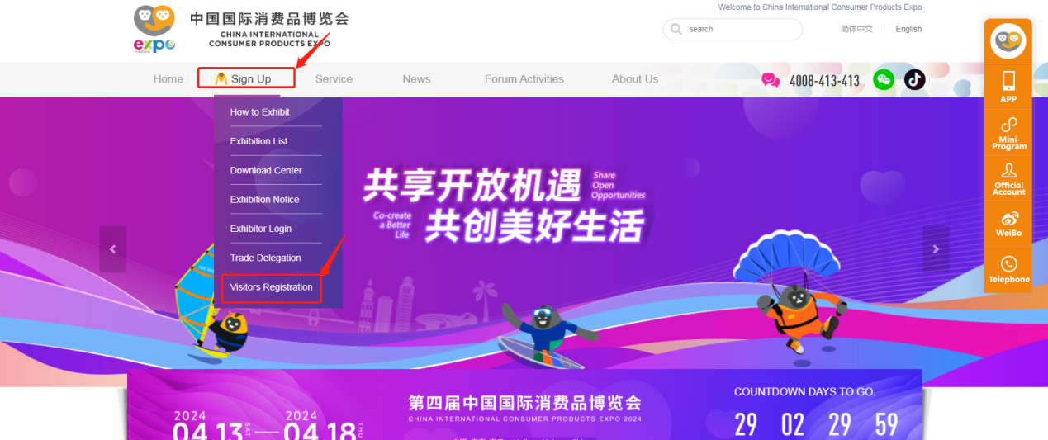
- Account Registration: Email Verification；
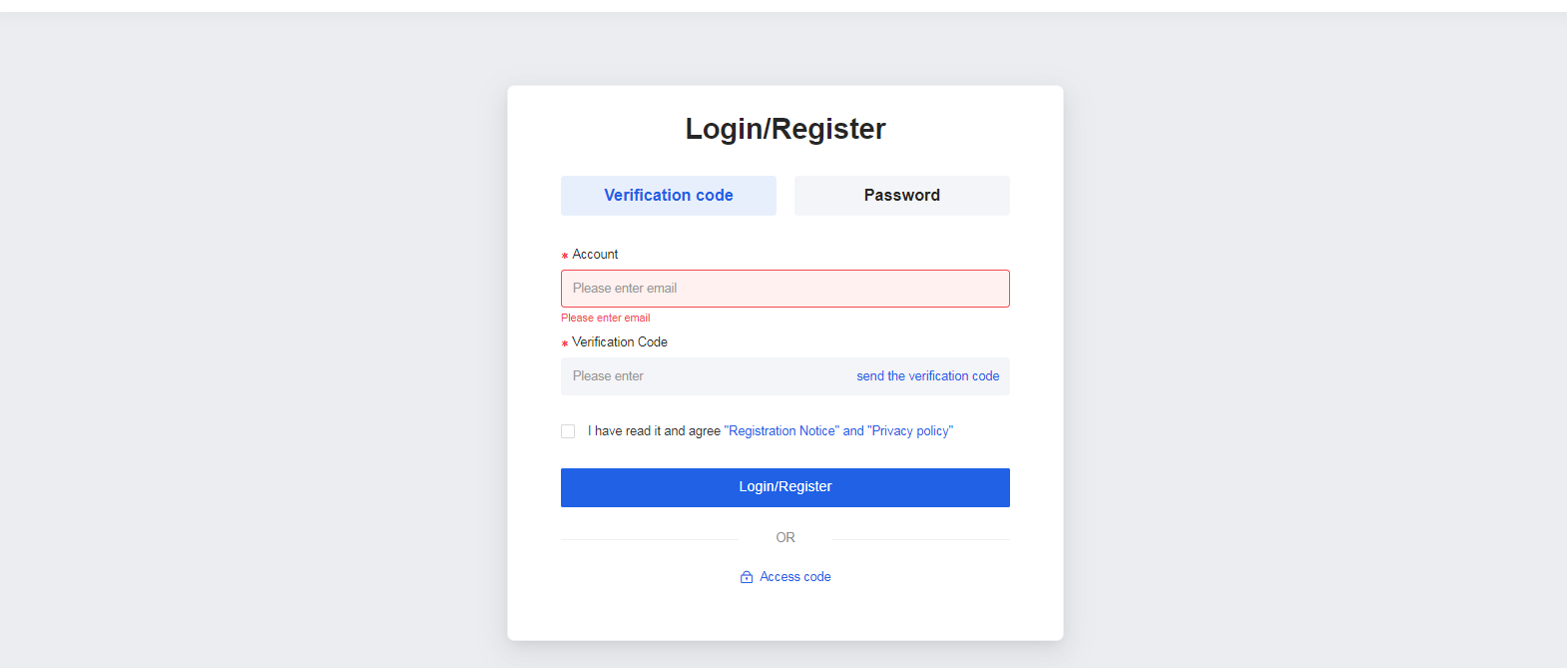
- Please fill in the registration information for professional visitors and click on "Next" to proceed.；
Note: When selecting "Postal Delivery" as the preferred method of receiving, please provide accurate recipient information
When selecting the option "On-site Collection" as the preferred method of receiving, please collect the badge in person at the Exhibition Badge Center.
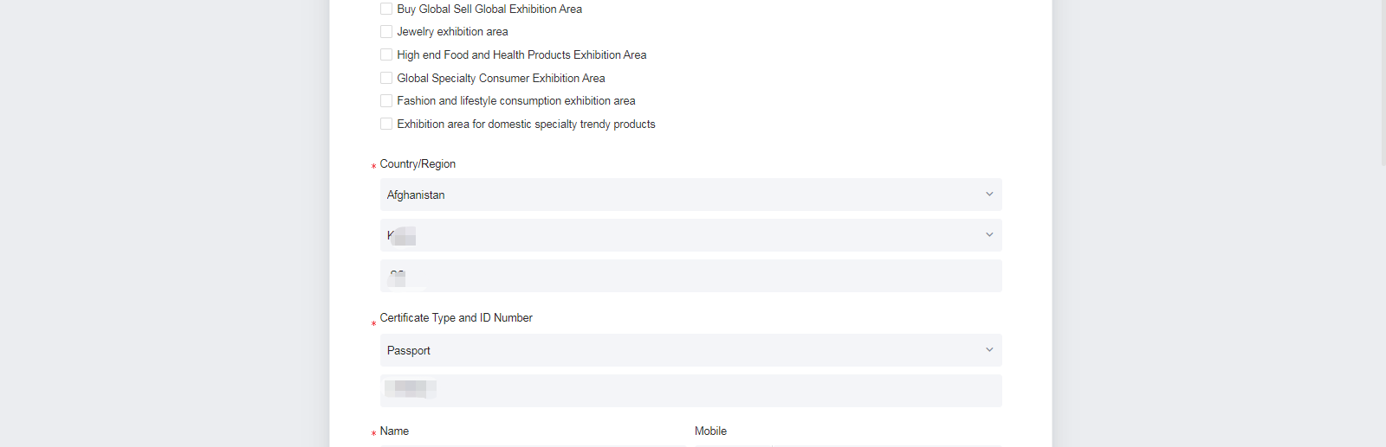
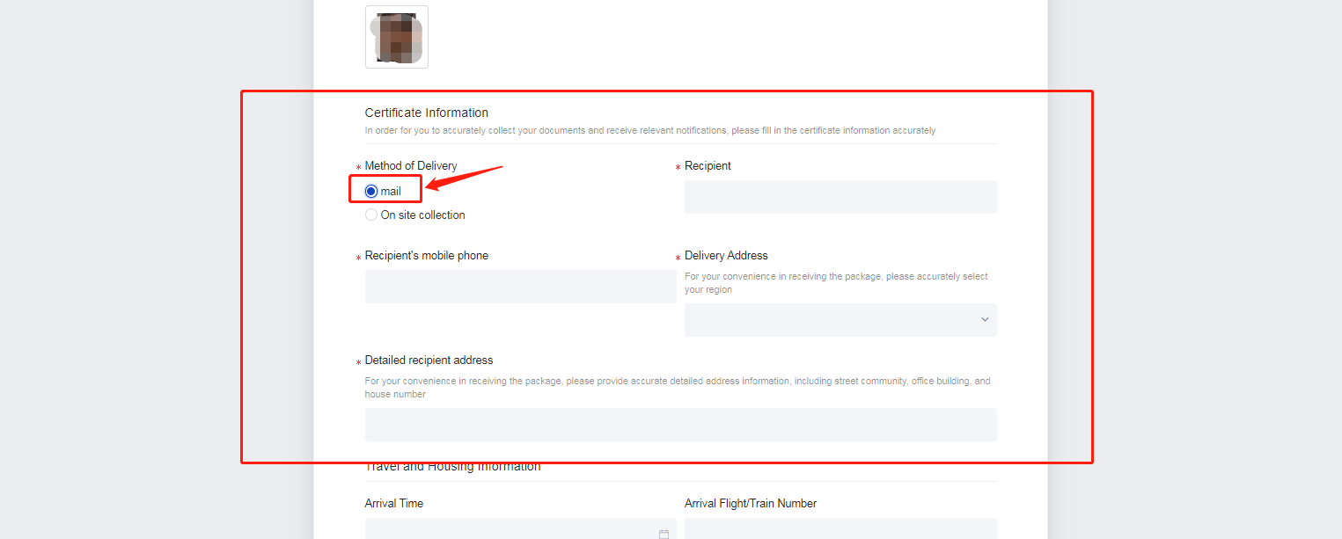
Attention:
- If you reside in China but do not have a Chinese ID card, please select your nationality in the "Country/Region" field and provide your passport information.
- If you have a Chinese mobile phone number, you can click to change the phone area code.
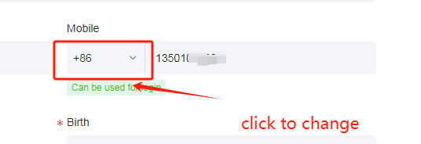
（3）Please review your information to ensure its accuracy.
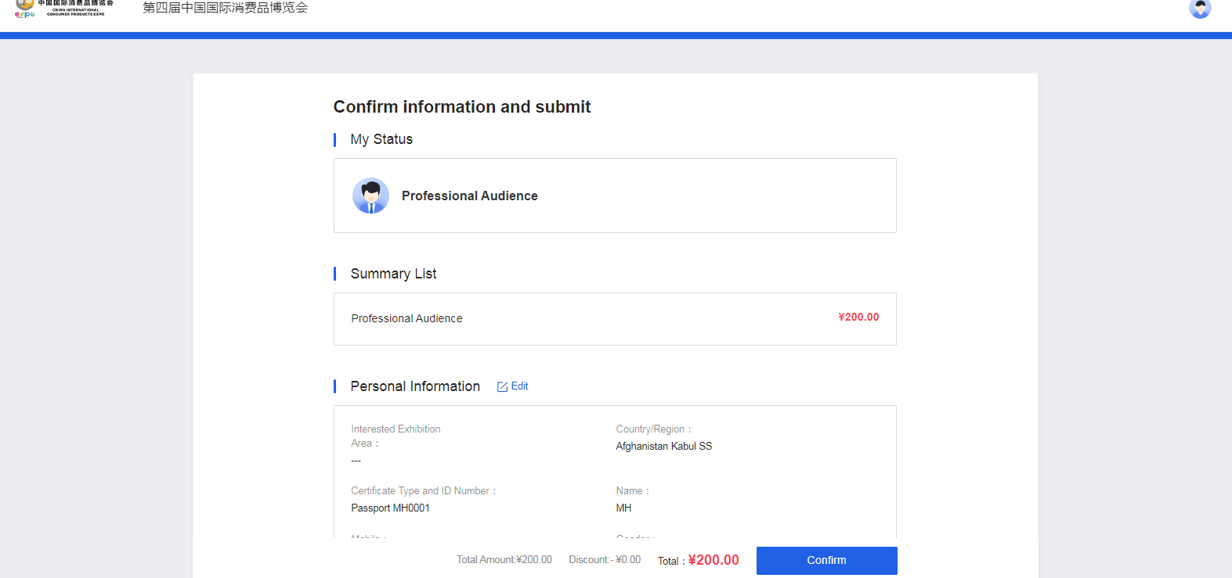

（4）After confirming your information, please submit it and wait for the organizer's review. Once your registration is approved, you can proceed with payment. After completing the payment, you will have successfully registered as a professional visitor.
二、Login
After submitting your information, you can access the personal center page through the "Professional Visitors" section on the official website. Use the email verification code to enter the personal center page. From there, you can check the status of your application review and badge production. Once your application is approved, proceed with the payment to complete the registration process.
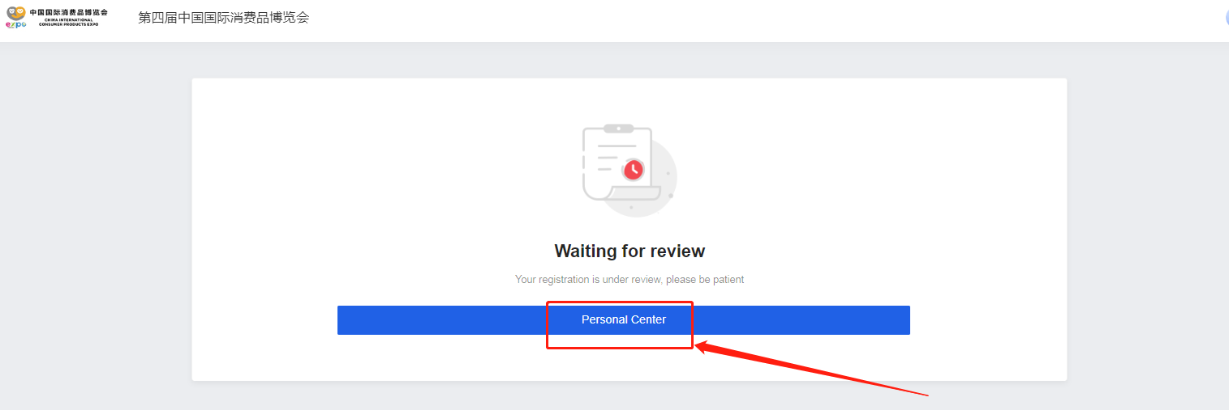
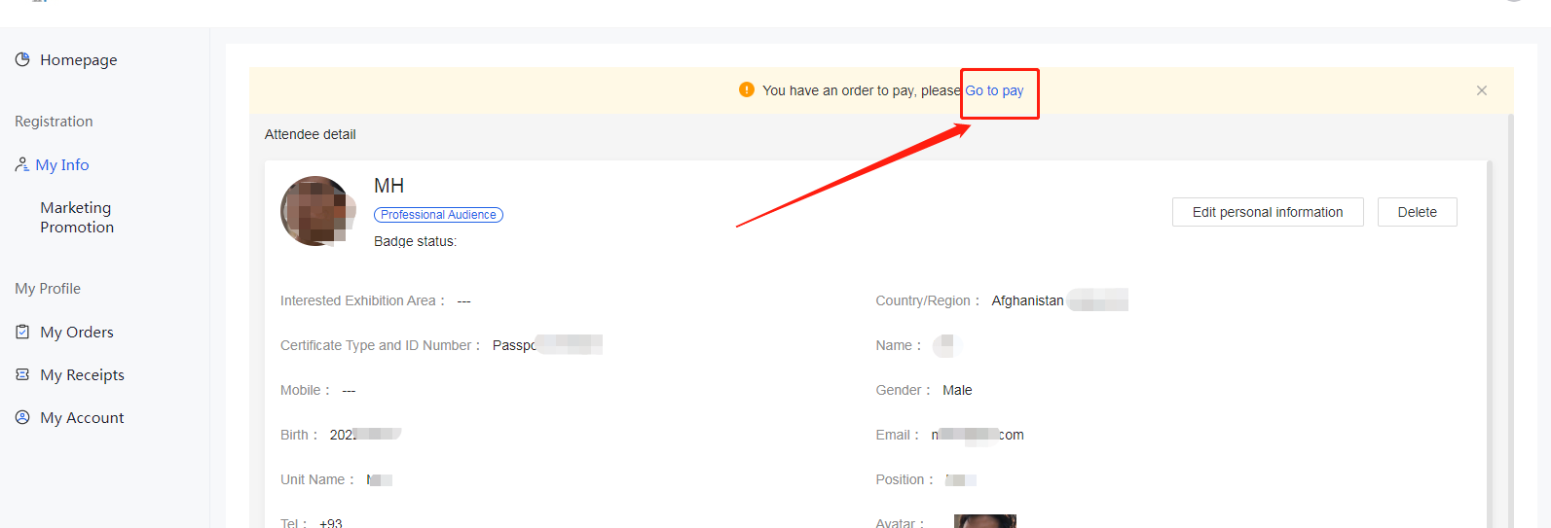

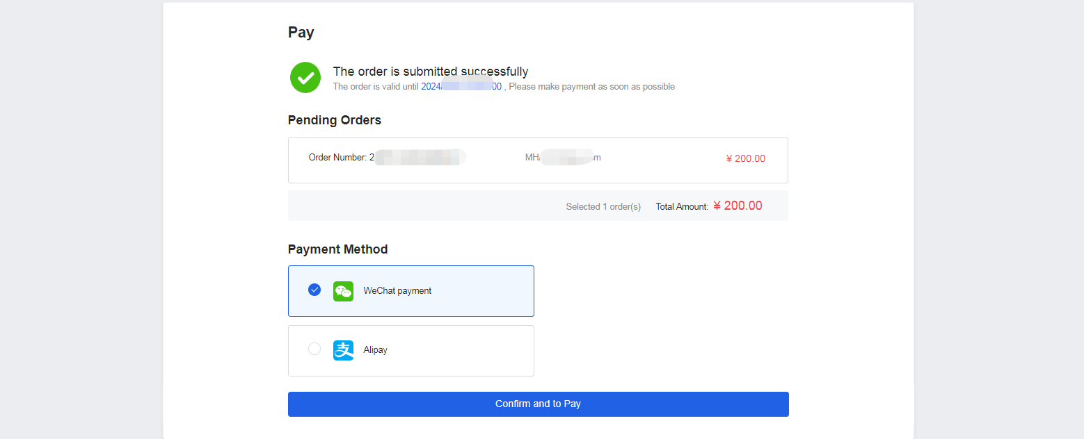

- Basic Information: You can view your badge production status here.
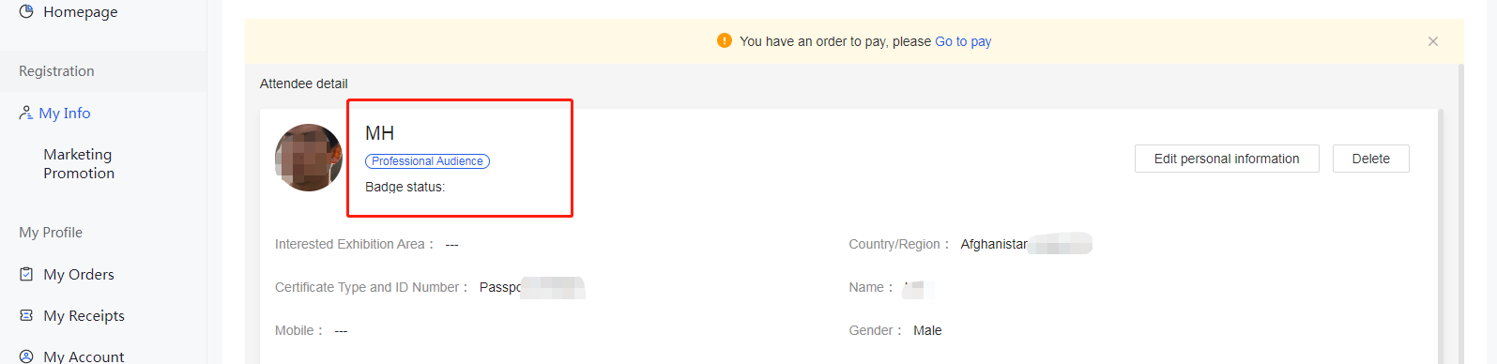
（2）Account Information: You can modify your phone number, which is used for login, as well as manage settings such as email and password here.

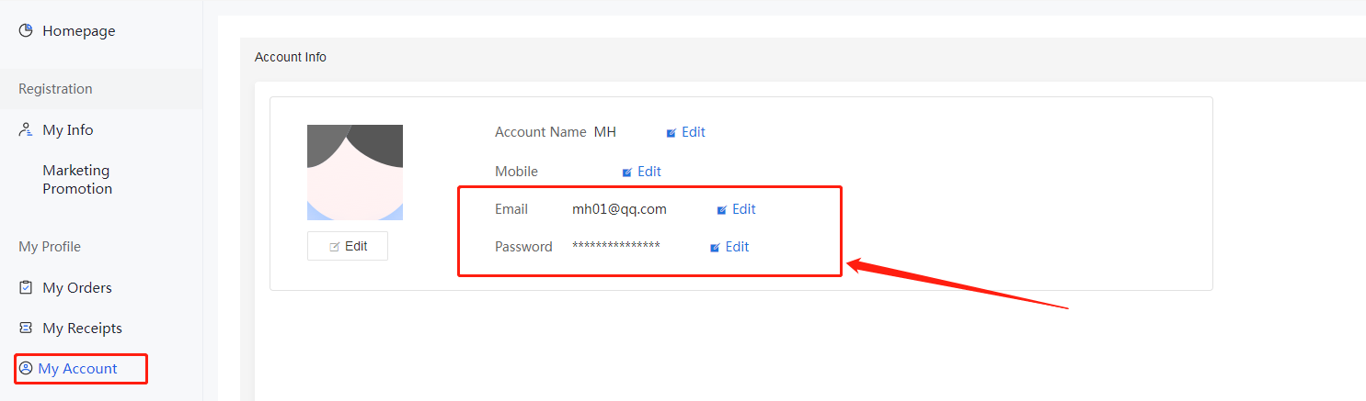

2024 Consumer Expo Professional Visitor Registration Mobile User Manual

一、Register
1、Enter the official website of China International Consumer Products Expo and click on the "Visitors Registration" .：
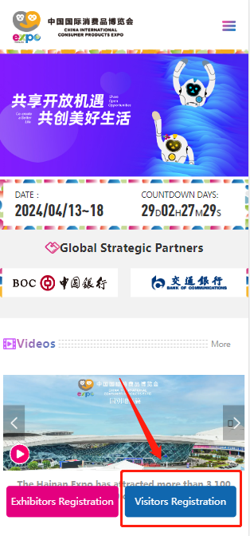
（1）Account Registration: Email Verification；
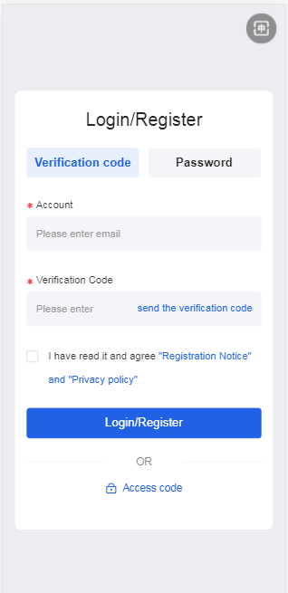
（2）Please fill in the registration information for professional visitors and click on "Next" to proceed.；
Note: When selecting "Postal Delivery" as the preferred method of receiving, please provide accurate recipient information
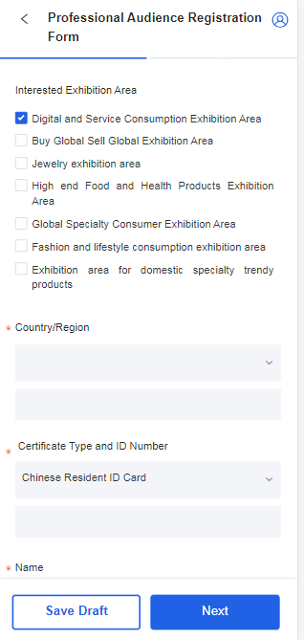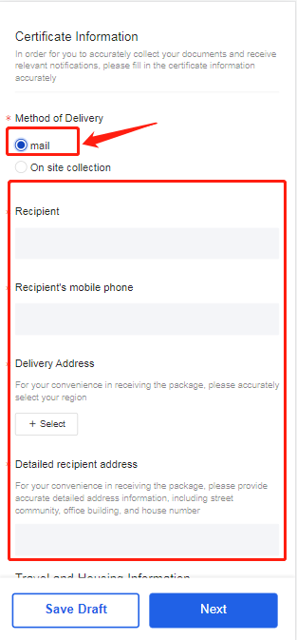
（3）Please review your information to ensure its accuracy.
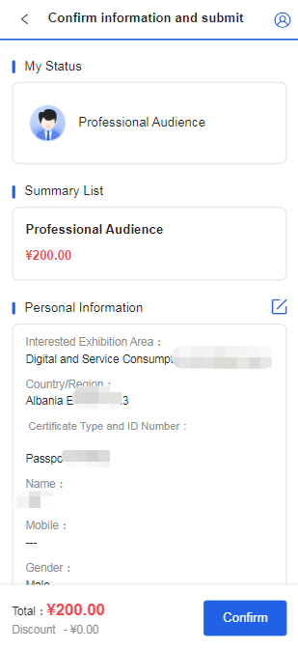

（4）After confirming your information, please submit it and wait for the organizer's review. Once your registration is approved, you can proceed with payment. After completing the payment, you will have successfully registered as a professional visitor.
二、Login
After submitting your information, you can access the personal center page through the "Professional Visitors" section on the official website. Use the email verification code to enter the personal center page. From there, you can check the status of your application review and badge production. Once your application is approved, proceed with the payment to complete the registration process.
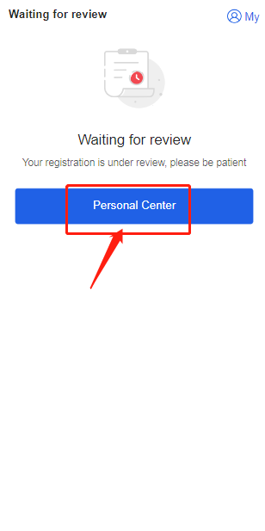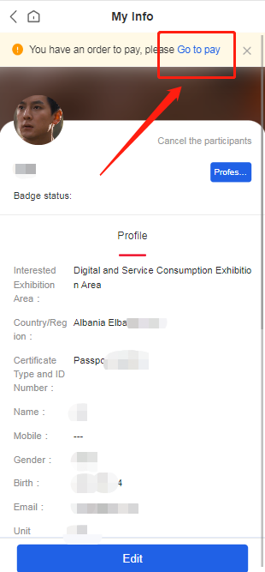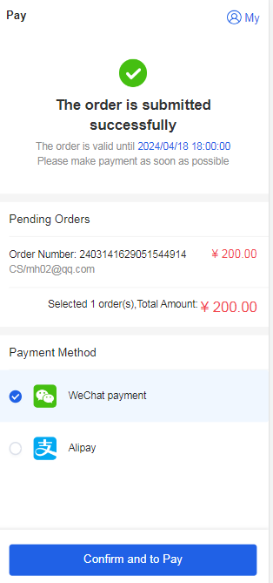

- Basic Information: You can view your badge production status here.
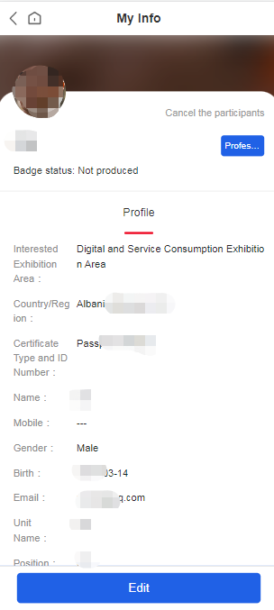
（2）Account Information: You can modify your phone number, which is used for login, as well as manage settings such as email and password here.
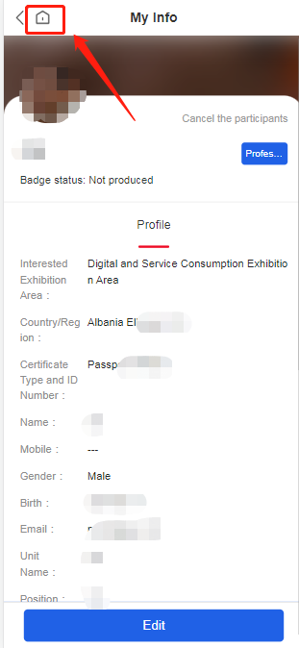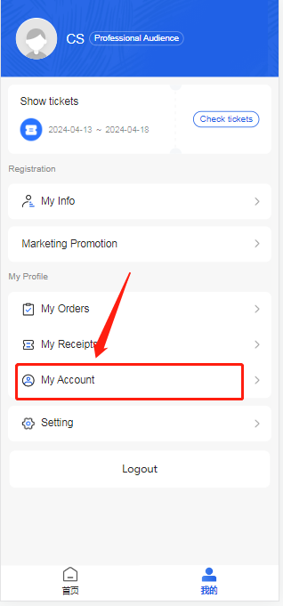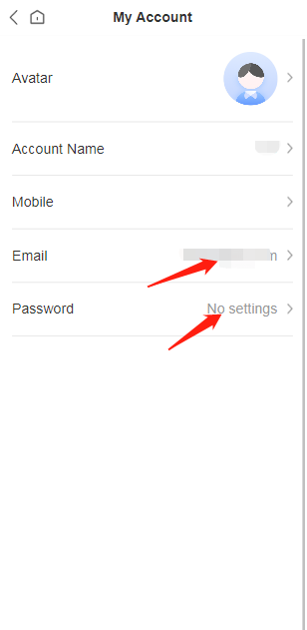

Information Filling Guidelines
1.Name and identification number (such as ID card number or passport number) must be filled in exactly as per the individual's identification document.
2.The photo is used for creating a personal identification document for accessing the exhibition hall. Please adhere to the following requirements:
- Upload a recent, full-face, color photo taken within the past year.
- Use a solid-color background with clear image quality, complete facial features, no beautification effects, and no sunglasses.
- The file size should be within 2MB.
- Acceptable formats: JPG/PNG.
3.If the ID type is a passport, Mainland Travel Permit for Hong Kong and Macau Residents, or Mainland Travel Permit for Taiwan Residents, ensure that the information provided precisely matches the details on the identification document. When filling in the name and identification number, pay attention to uppercase and lowercase letters and avoid entering special characters.
4.*When selecting "By Mail" in the collection method column, accurate information must be provided for "Mailing Address," "Recipient," and "Recipient's Mobile Phone."

